**ITIS 6177- System Integration**

**Final Project**

**Submitted by: Dileep Kumar Komatineni**

**Student ID: 801261197**

**API:** [**Language Service**](https://azure.microsoft.com/en-us/services/cognitive-services/language-service/) **-**[**Entity Recognition**](https://docs.microsoft.com/en-us/azure/cognitive-services/language-service/named-entity-recognition/overview)

**Named Entity Recognition :** Named Entity Recognition (NER) is a well-known job that is utilized in a variety of information retrieval applications, including indexing and text mining. The goal of NER systems is to find important names and proper names in a text and classify them into predetermined categories. Persons, locations, and organizations are the three basic classes utilized for named entity labeling.

API Endpoints:

/EntityRecognition **:** Detects entities found in text.

**Method: POST**

**Headers:**

Content-type: application/json

**Body Param: should be a JSON:**

{

"inputText":["Microsoft was founded by Bill Gates and Paul Allen on April 4, 1975, to develop and sell BASIC interpreters for the Altair 8800","La sede principal de Microsoft se encuentra en la ciudad de Redmond, a 21 kilómetros de Seattle."]

}

Request Screenshot:

Response Screenshot :

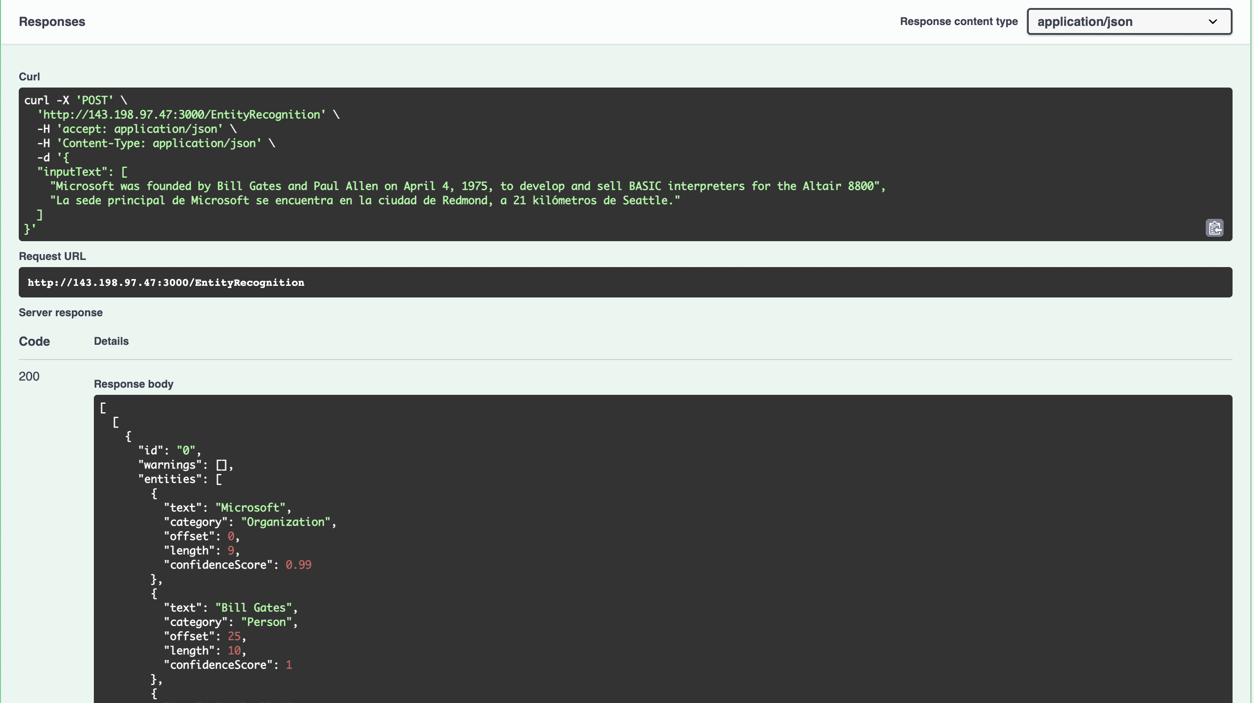

**Entity Linking:** Entity linking identifies and disambiguates the identity of entities found in text. For example, in the sentence "We went to Seattle last week.", the word "Seattle" would be identified, with a link to more information on Wikipedia.

/EntityLinking**:** identify and disambiguates the identity of entities found in text

**Method: POST**

**Headers:**

Content-type: application/json

**Body Param: should be a JSON:**

{

"SampleText":["Microsoft was founded by Bill Gates and Paul Allen on April 4, 1975, to develop and sell BASIC interpreters for the Altair 8800. During his career at Microsoft, Gates held the positions of chairman, chief executive officer, president and chief software architect, while also being the largest individual shareholder until May 2014."]

}

Request Screenshot:

Response Screenshot:

**Personally Identifiable Information (PII) :** The PII detection feature can identify, categorize, and redact sensitive information in unstructured text. For example: phone numbers, email addresses, and forms of identification.

**/pii :** identify, categorize, and redact sensitive information in text.

**Method: POST**

**Headers:**

Content-type: application/json

**Body Param: should be a JSON:**

{

"PIIText": [" ashok mobile number is 555-555-5555"]

}

Screenshot:

Response screenshot:

